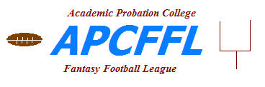

Academic Probation College Fantasy Football League
(APCFFL)

Physical Database Design

03/05/07
Version 1.0.3
Document History

Note: To change the Release Date (below, on cover page, and in document footer), update File-Properties-Custom tab-Date Completed.

Revision History
Date of this release: 11/8/2026 |  |  |  | Save Date: 11/8/2026
Create Date: here |  |  |  | Printed on:
Version | Revision Date |  | Summary of Changes |  | Author/Editor Name
0.0.1 | 04/23/04 | Initial Version |  |  | Dan Kamp
0.0.2 | 08/12/04 | Added KEY table |  |  | Dan Kamp
0.0.3 | 08/16/04 | Made Year a key in the STATS_MARGIN_OF_VICTORY table |  |  | Dan Kamp
0.0.4 | 08/24/04 | Add tables MESSAGE_BOARD and ANNOUNCEMENTS |  |  | Dan Kamp
1.0.0 | 03/14/05 | Finalize db model for development |  |  | Dan Kamp
1.0.1 | 03/18/05 | Add CONFIG table |  |  | Dan Kamp
1.0.2 | 01/15/07 | Modify the following:  Make TEAM_ID part of primary key of LINEUP_UNIT  Change USER to be a parent of OWNER  Add columns to BID  CONTINGENT_CHILD_BID (FK)  STATUS |  |  | Dan Kamp
1.0.3 | 03/05/07 | Modify the following  SCHOOL  Remove any reference to TEAM or LEAGUE  Create the following  TEAM_ROSTER |  |  | Dan Kamp

Table of Contents

1 Preface 4
2 Purpose 5
3 Information Model Diagram for each Physical Database Design Subject Area 6
10 - Calendar 7
20 – League Structure 8
30 – Season Schedule 9
40 - School 10
50 - Rosters 11
60 – Weekly Lineup 12
70 – Standings and Results 13
75 - Bowls 14
80 - Bids 15
90 – Security and Logging 16
900 - Stats 17
910 - Messages/Announcements 18
4 Table and Column Names 19
5 Tables 24
6 DDL - Step 1: Create Tables and Indexes, with and without Tablespace references 25
7 DDL - Step 2: Create Primary Key constraints 25
8 DDL - Step 3: Create Foreign Key constraints 25
9 Abbreviations 26
10 Index 27

Preface
The Physical Database Design work product maps the logical data model to the target database management system (DBMS) in a manner that meets the system’s performance requirements. The Physical Database Design converts logical data model entities to physical storage constructs (e.g., tables, files, and cylinders) of the target DBMS and secondary storage medium.

The Physical Database Design was created and maintained using this tool:

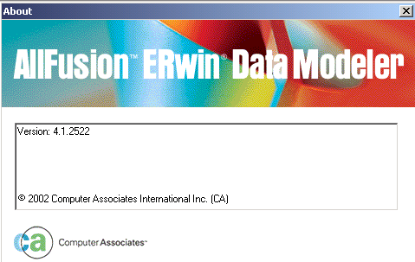

Purpose
The purpose of the Physical Database Design is to ensure that every database transaction meets or exceeds its performance requirements while reflecting the semantics of the logical data model. While the logical data model contains the information requirements of the system in a normalized form, a direct implementation of the model is unlikely to meet performance requirements. Physical Database Design takes into account data and transaction volume to produce a schema and environment that will meet necessary performance.

The Physical Database Design is composed of the Data Definition Language (DDL) that implements the database, an information model representing the physical structures and data elements making up the database, and entries in the data dictionary documenting the structures and elements of the design.

A complete Physical Database Design will contain:
- The DDL necessary to implement a database implementing the business semantics and rules as well as meets performance requirements.
- An information model documenting the physical structure of the database.
- Each entity in the information model will represent a physical structure of the database.
- Each entity will reflect the normalization decisions made during tuning.
- Each entity and attribute will be described in the data dictionary.
- A capacity assessment as appropriate.

Information Model Diagram for each Physical Database Design Subject Area
Here are the major data subject areas in APCFFL, presented in the sequence that makes most sense with regard to the APCFFL business processes that will be performed:

 | APCFFL Major Data Subject Area | Abbreviation
10 | Calendar
20 | League Structure
30 | Season Schedule
40 | School
50 | Rosters
60 | Weekly Lineup
70 | Standings and Results
75 | Bowls
80 | Bids
90 | Security and Logging
900 | Stats
910 | Messages / Announcements

Table 1 - APCFFL Data Subject Areas
This chapter displays diagrams of the tables, columns and relationships within each APCFFL Major Data Subject Area.

However, to enhance readability, these Major Data Subject Areas have been partitioned into smaller Subject Areas. The name of each smaller Subject Area incorporates the Abbreviation from “Table 1 - APCFFL Data Subject Areas” to clarify which APCFFL Major Data Subject Area it pertains to.

10 - Calendar
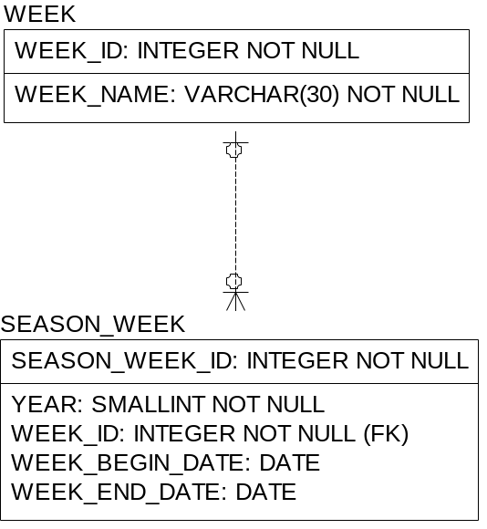

20 – League Structure
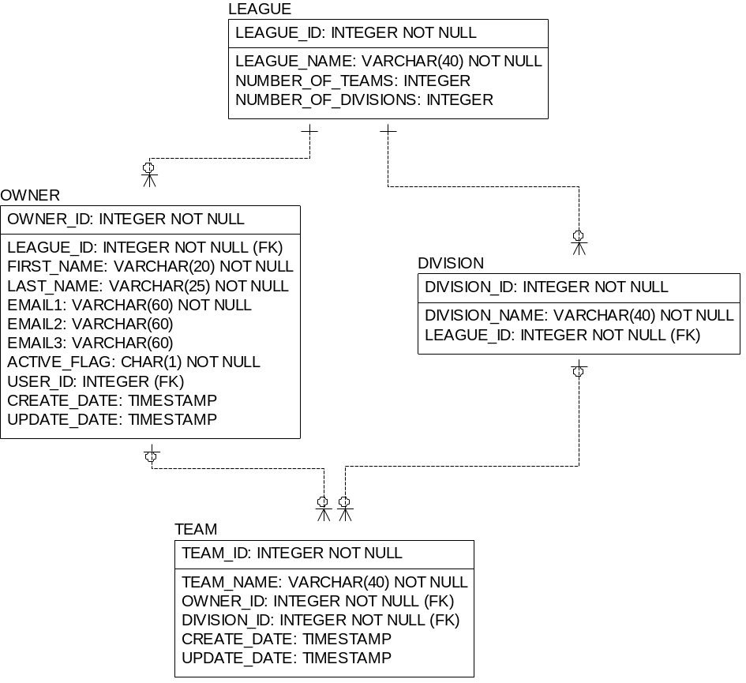

30 – Season Schedule
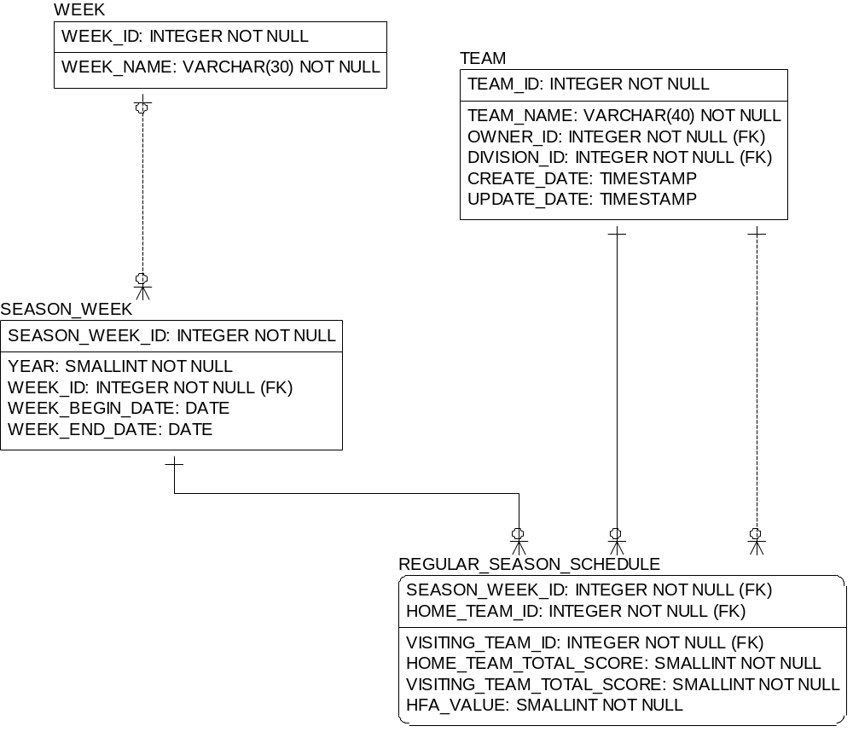

40 - School
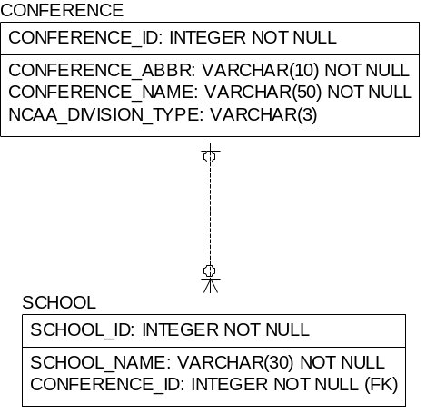

50 - Rosters
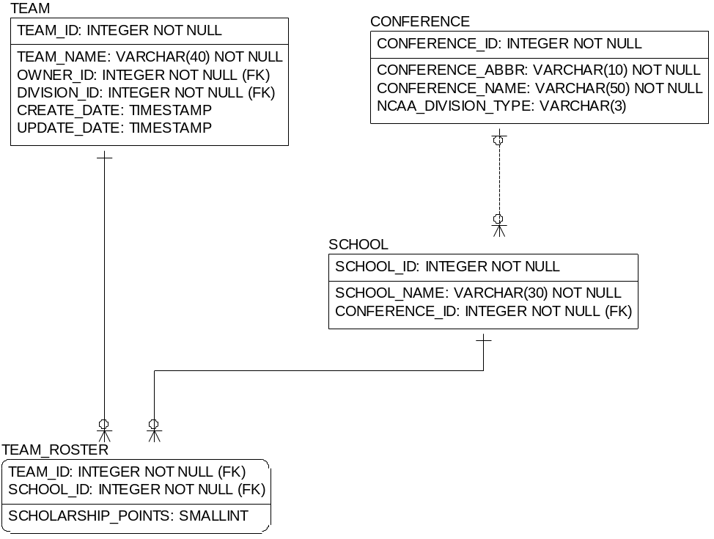

60 – Weekly Lineup
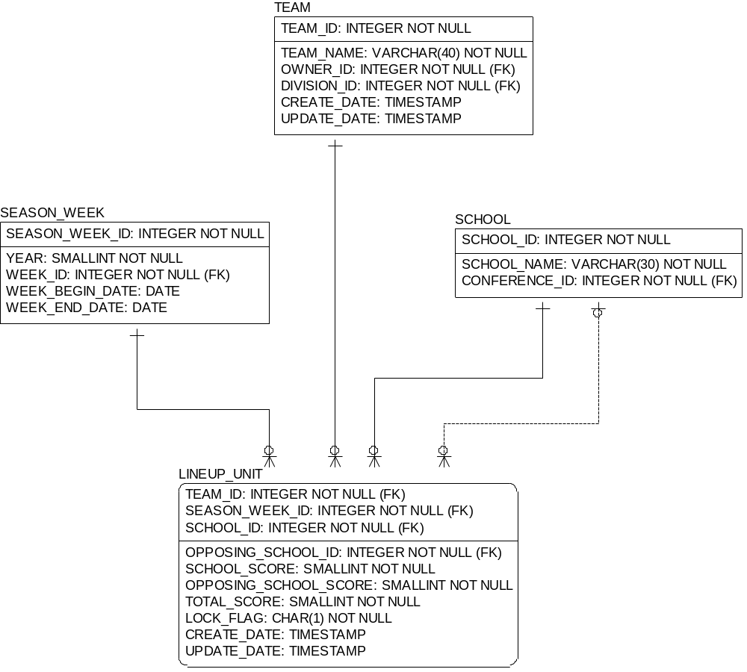

70 – Standings and Results
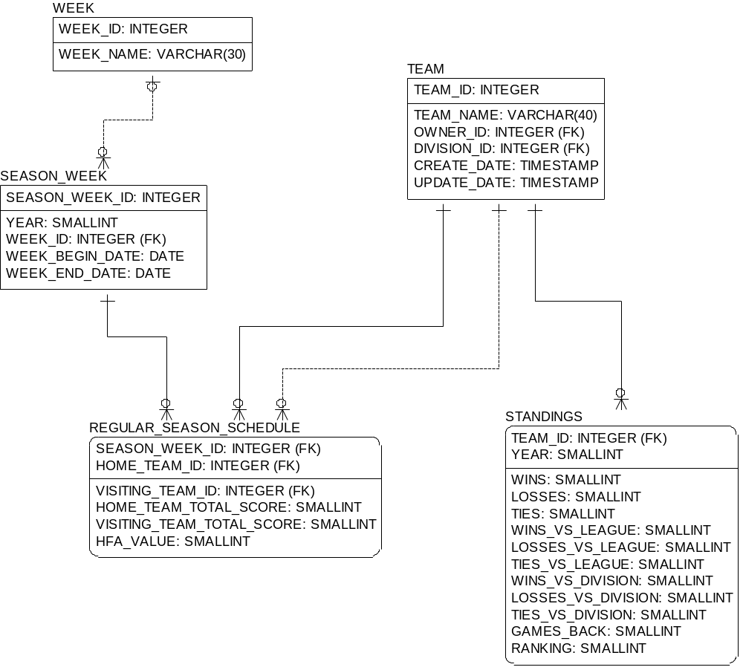

75 - Bowls
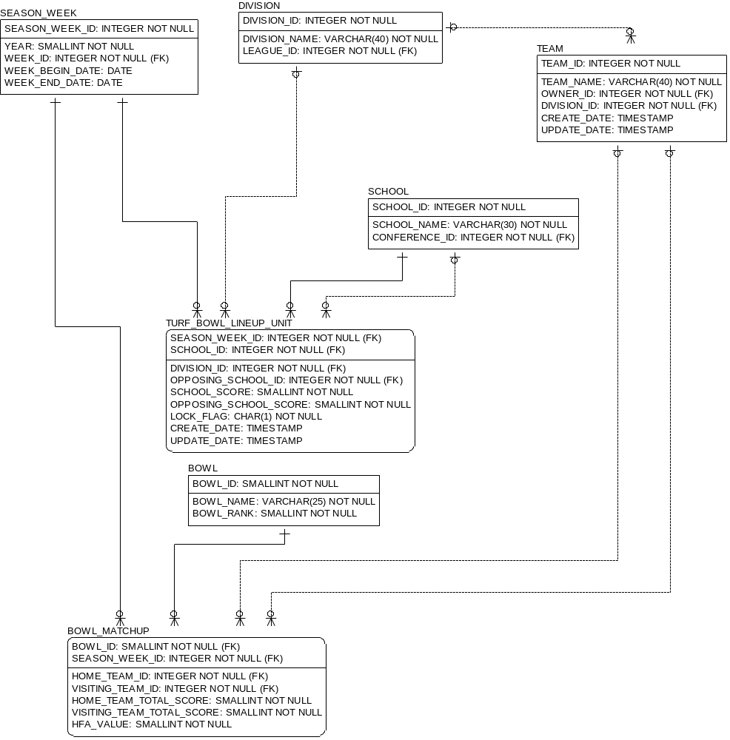

80 - Bids
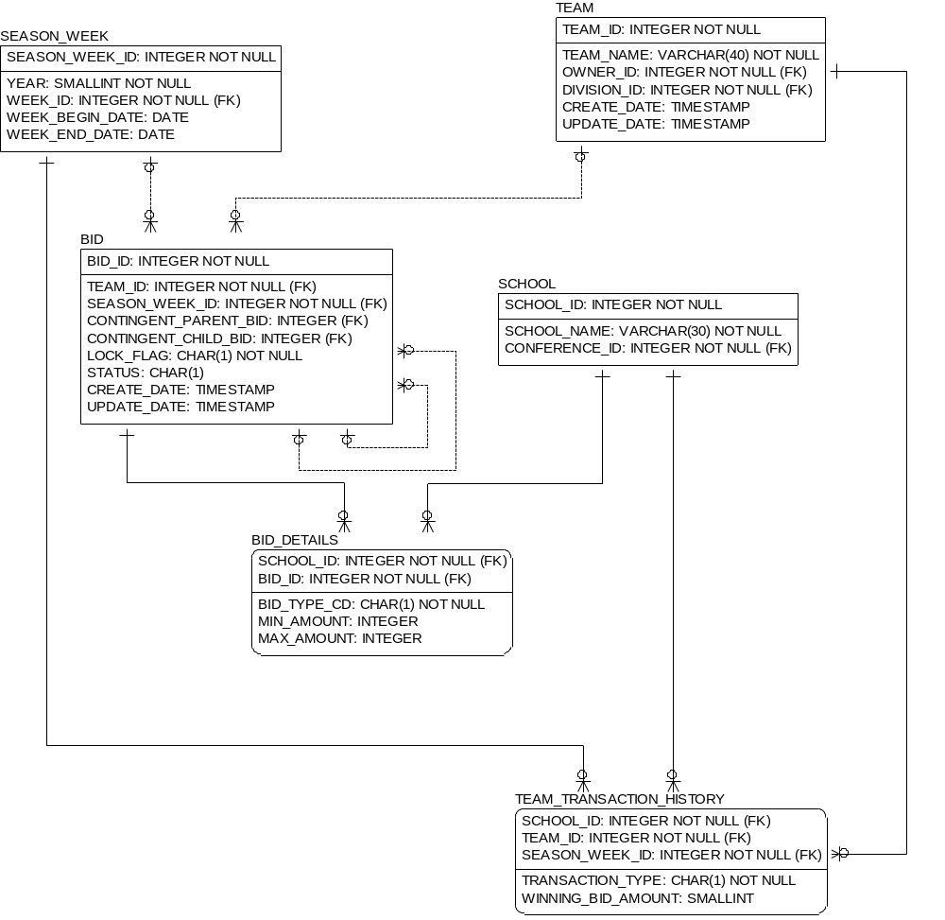

90 – Security and Logging
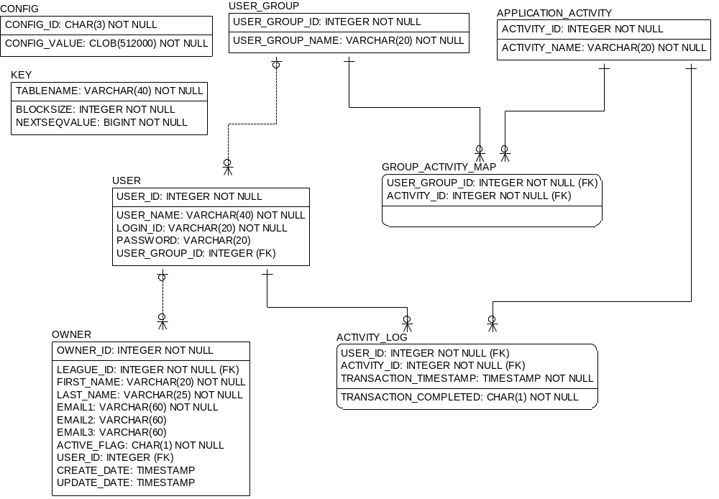

900 - Stats
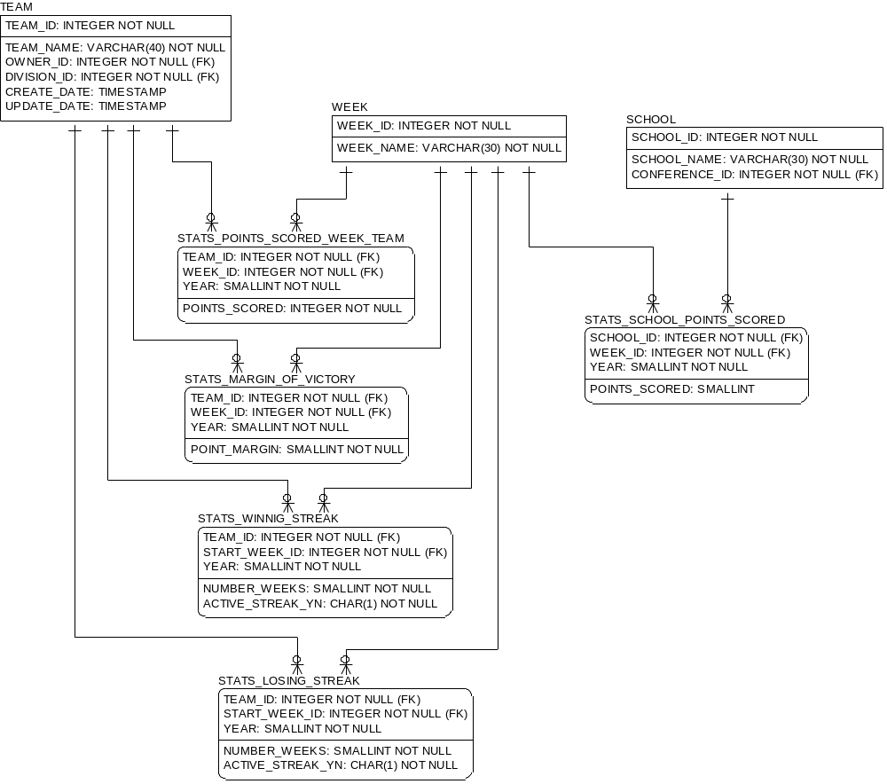

910 - Messages/Announcements
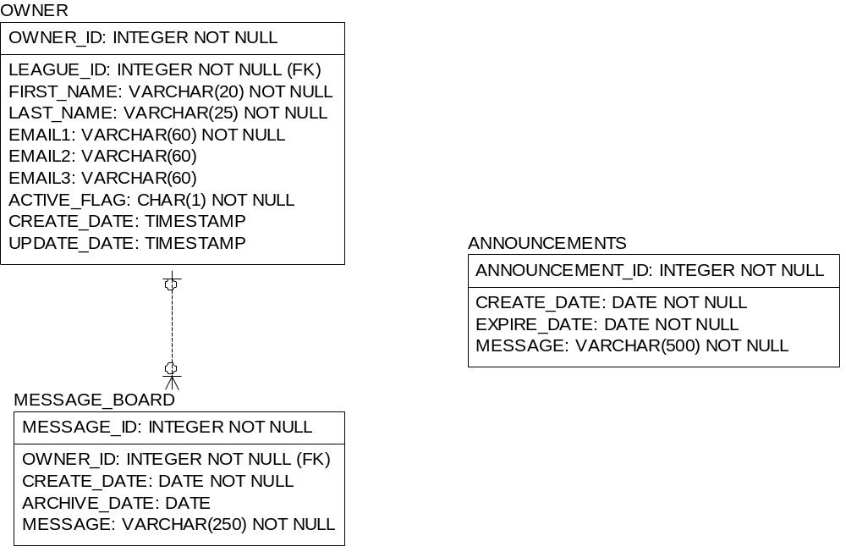

Table and Column Names
Table Name | Column Name | Column Datatype | Null  Option | PK ? | FK ? | Column Comment
ACTIVITY_LOG | USER_ID | INTEGER | NOT NULL | Yes | Yes
ACTIVITY_LOG | ACTIVITY_ID | INTEGER | NOT NULL | Yes | Yes
ACTIVITY_LOG | TRANSACTION_TIMESTAMP | TIMESTAMP | NOT NULL | Yes | No
ACTIVITY_LOG | TRANSACTION_COMPLETED | CHAR(1) | NOT NULL | No | No
ANNOUNCEMENTS | ANNOUNCEMENT_ID | INTEGER | NOT NULL | Yes | No
ANNOUNCEMENTS | CREATE_DATE | DATE | NOT NULL | No | No
ANNOUNCEMENTS | EXPIRE_DATE | DATE | NOT NULL | No | No
ANNOUNCEMENTS | MESSAGE | VARCHAR(500) | NOT NULL | No | No
APPLICATION_ACTIVITY | ACTIVITY_ID | INTEGER | NOT NULL | Yes | No
APPLICATION_ACTIVITY | ACTIVITY_NAME | VARCHAR(20) | NOT NULL | No | No
BID | BID_ID | INTEGER | NOT NULL | Yes | No
BID | TEAM_ID | INTEGER | NOT NULL | No | Yes | Unique identifier for a team
BID | SEASON_WEEK_ID | INTEGER | NOT NULL | No | Yes | Unique identifier for a week in a season
BID | CONTINGENT_PARENT_BID | INTEGER | NULL | No | Yes
BID | CONTINGENT_CHILD_BID | INTEGER | NULL | No | Yes
BID | LOCK_FLAG | CHAR(1) | NOT NULL | No | No
BID | STATUS | CHAR(1) | NULL | No | No | Status can be either:  A - Bid is active  I - Bid is inactive (i.e., deleted)
BID | CREATE_DATE | TIMESTAMP | NULL | No | No
BID | UPDATE_DATE | TIMESTAMP | NULL | No | No
BID_DETAILS | SCHOOL_ID | INTEGER | NOT NULL | Yes | Yes | Unique identifier of the school.
BID_DETAILS | BID_ID | INTEGER | NOT NULL | Yes | Yes
BID_DETAILS | BID_TYPE_CD | CHAR() | NOT NULL | No | No | 'D' - Drop School  'A' - Add School
BID_DETAILS | MIN_AMOUNT | INTEGER | NULL | No | No
BID_DETAILS | MAX_AMOUNT | INTEGER | NULL | No | No
BOWL | BOWL_ID | SMALLINT | NOT NULL | Yes | No
BOWL | BOWL_NAME | VARCHAR(25) | NOT NULL | No | No
BOWL | BOWL_RANK | SMALLINT | NOT NULL | No | No
BOWL_MATCHUP | BOWL_ID | SMALLINT | NOT NULL | Yes | Yes
BOWL_MATCHUP | SEASON_WEEK_ID | INTEGER | NOT NULL | Yes | Yes | Unique identifier for a week in a season
BOWL_MATCHUP | HOME_TEAM_ID | INTEGER | NOT NULL | No | Yes | Unique identifier for a team
BOWL_MATCHUP | VISITING_TEAM_ID | INTEGER | NOT NULL | No | Yes | Unique identifier for a team
BOWL_MATCHUP | HOME_TEAM_TOTAL_SCORE | SMALLINT | NOT NULL | No | No
BOWL_MATCHUP | VISITING_TEAM_TOTAL_SCORE | SMALLINT | NOT NULL | No | No
BOWL_MATCHUP | HFA_VALUE | SMALLINT | NOT NULL | No | No
CONFERENCE | CONFERENCE_ID | INTEGER | NOT NULL | Yes | No | Unique conference identifier
CONFERENCE | CONFERENCE_ABBR | VARCHAR(10) | NOT NULL | No | No | Name of the NCAA Division 1A conference.  Members will include:  ACC  Big 10  Big 12  Big East  IND  MAC  MW  PAC 10  SEC  USA  WAC
CONFERENCE | CONFERENCE_NAME | VARCHAR(50) | NOT NULL | No | No | Full name of the conference.
CONFERENCE | NCAA_DIVISION_TYPE | VARCHAR(3) | NULL | No | No
CONFIG | CONFIG_ID | CHAR(3) | NOT NULL | Yes | No
CONFIG | CONFIG_VALUE | CLOB(512000) | NOT NULL | No | No
DIVISION | DIVISION_ID | INTEGER | NOT NULL | Yes | No | Unique identifier of a division
DIVISION | DIVISION_NAME | VARCHAR(40) | NOT NULL | No | No | Division name (i.e., Artificial Turf, Natural Grass)
DIVISION | LEAGUE_ID | INTEGER | NOT NULL | No | Yes
GROUP_ACTIVITY_MAP | USER_GROUP_ID | INTEGER | NOT NULL | Yes | Yes
GROUP_ACTIVITY_MAP | ACTIVITY_ID | INTEGER | NOT NULL | Yes | Yes
KEY | TABLENAME | VARCHAR(40) | NOT NULL | Yes | No
KEY | BLOCKSIZE | INTEGER | NOT NULL | No | No
KEY | NEXTSEQVALUE | BIGINT | NOT NULL | No | No
LEAGUE | LEAGUE_ID | INTEGER | NOT NULL | Yes | No
LEAGUE | LEAGUE_NAME | VARCHAR(40) | NOT NULL | No | No
LEAGUE | NUMBER_OF_TEAMS | INTEGER | NULL | No | No
LEAGUE | NUMBER_OF_DIVISIONS | INTEGER | NULL | No | No
LINEUP_UNIT | SEASON_WEEK_ID | INTEGER | NOT NULL | Yes | Yes | Unique identifier for a week in a season
LINEUP_UNIT | TEAM_ID | INTEGER | NOT NULL | Yes | Yes | Unique identifier for a team
LINEUP_UNIT | SCHOOL_ID | INTEGER | NOT NULL | Yes | Yes | Unique identifier of the school.
LINEUP_UNIT | OPPOSING_SCHOOL_ID | INTEGER | NOT NULL | No | Yes | Unique identifier of the school.
LINEUP_UNIT | SCHOOL_SCORE | SMALLINT | NOT NULL | No | No
LINEUP_UNIT | OPPOSING_SCHOOL_SCORE | SMALLINT | NOT NULL | No | No
LINEUP_UNIT | TOTAL_SCORE | SMALLINT | NOT NULL | No | No
LINEUP_UNIT | LOCK_FLAG | CHAR(1) | NOT NULL | No | No | Flag indicating of the lineup is locked. Lineups are locked once the deadline has passed and may not be changed.
LINEUP_UNIT | CREATE_DATE | TIMESTAMP | NULL | No | No
LINEUP_UNIT | UPDATE_DATE | TIMESTAMP | NULL | No | No
MESSAGE_BOARD | MESSAGE_ID | INTEGER | NOT NULL | Yes | No
MESSAGE_BOARD | OWNER_ID | INTEGER | NOT NULL | No | Yes | Unique identifier for a team owner
MESSAGE_BOARD | CREATE_DATE | DATE | NOT NULL | No | No
MESSAGE_BOARD | ARCHIVE_DATE | DATE | NULL | No | No
MESSAGE_BOARD | MESSAGE | VARCHAR(250) | NOT NULL | No | No
OWNER | OWNER_ID | INTEGER | NOT NULL | Yes | No | Unique identifier for a team owner
OWNER | LEAGUE_ID | INTEGER | NOT NULL | No | Yes
OWNER | FIRST_NAME | VARCHAR(20) | NOT NULL | No | No | Team owner's first name
OWNER | LAST_NAME | VARCHAR(25) | NOT NULL | No | No | Team owner's last name
OWNER | EMAIL1 | VARCHAR(60) | NOT NULL | No | No | Team owner's primary email address
OWNER | EMAIL2 | VARCHAR(60) | NULL | No | No | Team owner's secondary email address
OWNER | EMAIL3 | VARCHAR(60) | NULL | No | No | Team owner's tertiary email address
OWNER | ACTIVE_FLAG | CHAR(1) | NOT NULL | No | No
OWNER | USER_ID | INTEGER | NULL | No | Yes
OWNER | CREATE_DATE | TIMESTAMP | NULL | No | No
OWNER | UPDATE_DATE | TIMESTAMP | NULL | No | No
REGULAR_SEASON_SCHEDULE | SEASON_WEEK_ID | INTEGER | NOT NULL | Yes | Yes | Unique identifier for a week in a season
REGULAR_SEASON_SCHEDULE | HOME_TEAM_ID | INTEGER | NOT NULL | Yes | Yes | Unique identifier for a team
REGULAR_SEASON_SCHEDULE | VISITING_TEAM_ID | INTEGER | NOT NULL | No | Yes | Unique identifier for a team
REGULAR_SEASON_SCHEDULE | HOME_TEAM_TOTAL_SCORE | SMALLINT | NOT NULL | No | No
REGULAR_SEASON_SCHEDULE | VISITING_TEAM_TOTAL_SCORE | SMALLINT | NOT NULL | No | No
REGULAR_SEASON_SCHEDULE | HFA_VALUE | SMALLINT | NOT NULL | No | No
SCHOOL | SCHOOL_ID | INTEGER | NOT NULL | Yes | No | Unique identifier of the school.
SCHOOL | SCHOOL_NAME | VARCHAR(30) | NOT NULL | No | No | Name of the school.
SCHOOL | CONFERENCE_ID | INTEGER | NOT NULL | No | Yes | Unique conference identifier
SEASON_WEEK | SEASON_WEEK_ID | INTEGER | NOT NULL | Yes | No | Unique identifier for a week in a season
SEASON_WEEK | YEAR | SMALLINT | NOT NULL | No | No | The year of the football season.  Example: 2003, 2004
SEASON_WEEK | WEEK_ID | INTEGER | NOT NULL | No | Yes | Unique identifier for a week in the football season.
SEASON_WEEK | WEEK_BEGIN_DATE | DATE | NULL | No | No | The date the week begins. Not all games are played on Saturday. Some start as early as Tuesday. This varies from week to week in a season.
SEASON_WEEK | WEEK_END_DATE | DATE | NULL | No | No | The end of the week when the last game is played. It always falls on the Saturday of the week.
STANDINGS | TEAM_ID | INTEGER | NOT NULL | Yes | Yes | Unique identifier for a team
STANDINGS | YEAR | SMALLINT | NOT NULL | Yes | No
STANDINGS | WINS | SMALLINT | NOT NULL | No | No
STANDINGS | LOSSES | SMALLINT | NOT NULL | No | No
STANDINGS | TIES | SMALLINT | NOT NULL | No | No
STANDINGS | WINS_VS_LEAGUE | SMALLINT | NOT NULL | No | No
STANDINGS | LOSSES_VS_LEAGUE | SMALLINT | NOT NULL | No | No
STANDINGS | TIES_VS_LEAGUE | SMALLINT | NOT NULL | No | No
STANDINGS | WINS_VS_DIVISION | SMALLINT | NOT NULL | No | No
STANDINGS | LOSSES_VS_DIVISION | SMALLINT | NOT NULL | No | No
STANDINGS | TIES_VS_DIVISION | SMALLINT | NOT NULL | No | No
STANDINGS | GAMES_BACK | SMALLINT | NOT NULL | No | No
STANDINGS | RANKING | SMALLINT | NOT NULL | No | No
STATS_LOSING_STREAK | TEAM_ID | INTEGER | NOT NULL | Yes | Yes | Unique identifier for a team
STATS_LOSING_STREAK | START_WEEK_ID | INTEGER | NOT NULL | Yes | Yes | Unique identifier for a week in the football season.
STATS_LOSING_STREAK | YEAR | SMALLINT | NOT NULL | Yes | No
STATS_LOSING_STREAK | NUMBER_WEEKS | SMALLINT | NOT NULL | No | No
STATS_LOSING_STREAK | ACTIVE_STREAK_YN | CHAR(1) | NOT NULL | No | No
STATS_MARGIN_OF_VICTORY | TEAM_ID | INTEGER | NOT NULL | Yes | Yes | Unique identifier for a team
STATS_MARGIN_OF_VICTORY | WEEK_ID | INTEGER | NOT NULL | Yes | Yes | Unique identifier for a week in the football season.
STATS_MARGIN_OF_VICTORY | YEAR | SMALLINT | NOT NULL | Yes | No
STATS_MARGIN_OF_VICTORY | POINT_MARGIN | SMALLINT | NOT NULL | No | No
STATS_POINTS_SCORED_WEEK_TEAM | TEAM_ID | INTEGER | NOT NULL | Yes | Yes | Unique identifier for a team
STATS_POINTS_SCORED_WEEK_TEAM | WEEK_ID | INTEGER | NOT NULL | Yes | Yes | Unique identifier for a week in the football season.
STATS_POINTS_SCORED_WEEK_TEAM | YEAR | SMALLINT | NOT NULL | Yes | No
STATS_POINTS_SCORED_WEEK_TEAM | POINTS_SCORED | INTEGER | NOT NULL | No | No
STATS_SCHOOL_POINTS_SCORED | SCHOOL_ID | INTEGER | NOT NULL | Yes | Yes | Unique identifier of the school.
STATS_SCHOOL_POINTS_SCORED | WEEK_ID | INTEGER | NOT NULL | Yes | Yes | Unique identifier for a week in the football season.
STATS_SCHOOL_POINTS_SCORED | YEAR | SMALLINT | NOT NULL | Yes | No
STATS_SCHOOL_POINTS_SCORED | POINTS_SCORED | SMALLINT | NULL | No | No
STATS_WINNIG_STREAK | TEAM_ID | INTEGER | NOT NULL | Yes | Yes | Unique identifier for a team
STATS_WINNIG_STREAK | START_WEEK_ID | INTEGER | NOT NULL | Yes | Yes | Unique identifier for a week in the football season.
STATS_WINNIG_STREAK | YEAR | SMALLINT | NOT NULL | Yes | No
STATS_WINNIG_STREAK | NUMBER_WEEKS | SMALLINT | NOT NULL | No | No
STATS_WINNIG_STREAK | ACTIVE_STREAK_YN | CHAR(1) | NOT NULL | No | No
TEAM | TEAM_ID | INTEGER | NOT NULL | Yes | No | Unique identifier for a team
TEAM | TEAM_NAME | VARCHAR(40) | NOT NULL | No | No | Team name
TEAM | OWNER_ID | INTEGER | NOT NULL | No | Yes | Unique identifier for a team owner
TEAM | DIVISION_ID | INTEGER | NOT NULL | No | Yes | Unique identifier of a division
TEAM | CREATE_DATE | TIMESTAMP | NULL | No | No
TEAM | UPDATE_DATE | TIMESTAMP | NULL | No | No
TEAM_ROSTER | TEAM_ID | INTEGER | NOT NULL | Yes | Yes
TEAM_ROSTER | SCHOOL_ID | INTEGER | NOT NULL | Yes | Yes
TEAM_ROSTER | SCHOLARSIHP_POINTS | SMALLINT | NULL | No | No
TEAM_TRANSACTION_HISTORY | SCHOOL_ID | INTEGER | NOT NULL | Yes | Yes | Unique identifier of the school.
TEAM_TRANSACTION_HISTORY | TEAM_ID | INTEGER | NOT NULL | Yes | Yes | Unique identifier for a team
TEAM_TRANSACTION_HISTORY | SEASON_WEEK_ID | INTEGER | NOT NULL | Yes | Yes | Unique identifier for a week in a season
TEAM_TRANSACTION_HISTORY | TRANSACTION_TYPE | CHAR(1) | NOT NULL | No | No
TEAM_TRANSACTION_HISTORY | WINNING_BID_AMOUNT | SMALLINT | NULL | No | No
TURF_BOWL_LINEUP_UNIT | SEASON_WEEK_ID | INTEGER | NOT NULL | Yes | Yes | Unique identifier for a week in a season
TURF_BOWL_LINEUP_UNIT | SCHOOL_ID | INTEGER | NOT NULL | Yes | Yes | Unique identifier of the school.
TURF_BOWL_LINEUP_UNIT | DIVISION_ID | INTEGER | NOT NULL | No | Yes | Unique identifier of a division
TURF_BOWL_LINEUP_UNIT | OPPOSING_SCHOOL_ID | INTEGER | NOT NULL | No | Yes | Unique identifier of the school.
TURF_BOWL_LINEUP_UNIT | SCHOOL_SCORE | SMALLINT | NOT NULL | No | No
TURF_BOWL_LINEUP_UNIT | OPPOSING_SCHOOL_SCORE | SMALLINT | NOT NULL | No | No
TURF_BOWL_LINEUP_UNIT | LOCK_FLAG | CHAR(1) | NOT NULL | No | No
TURF_BOWL_LINEUP_UNIT | CREATE_DATE | TIMESTAMP | NULL | No | No
TURF_BOWL_LINEUP_UNIT | UPDATE_DATE | TIMESTAMP | NULL | No | No
USER | USER_ID | INTEGER | NOT NULL | Yes | No
USER | USER_NAME | VARCHAR(40) | NOT NULL | No | No
USER | LOGIN_ID | VARCHAR(20) | NOT NULL | No | No
USER | PASSWORD | VARCHAR(20) | NULL | No | No
USER | USER_GROUP_ID | INTEGER | NULL | No | Yes
USER_GROUP | USER_GROUP_ID | INTEGER | NOT NULL | Yes | No
USER_GROUP | USER_GROUP_NAME | VARCHAR(20) | NOT NULL | No | No
WEEK | WEEK_ID | INTEGER | NOT NULL | Yes | No | Unique identifier for a week in the football season.
WEEK | WEEK_NAME | VARCHAR(30) | NOT NULL | No | No | The name of the week of the football season. Will be one of:  1  2  3  4  5  6  7  8  9  10  Bowl Week  Turf Bowl

Tables
Table Name | Row Count

DELIBERATELY OMITTED

DDL - Step 1: Create Tables and Indexes, with and without Tablespace references

See separate file for CREATE DDL.

DDL - Step 2: Create Primary Key constraints

See separate file for CREATE PRIMARY KEY DDL.

DDL - Step 3: Create Foreign Key constraints

See separate file for CREATE FOREIGN KEY DDL.

Abbreviations
These abbreviations were used to generate table names from the entity names within the Logical Data Model.

Abbrev | Keyword | Source

Index

